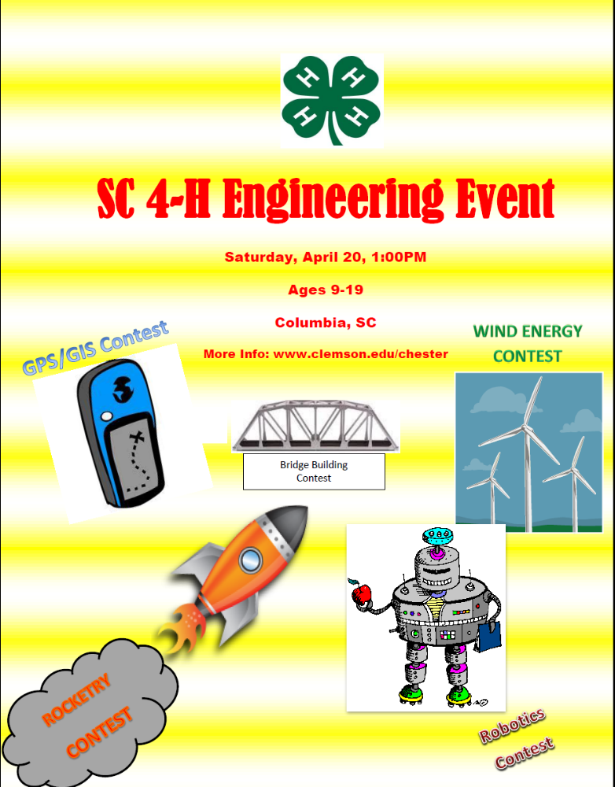

South Carolina 4-H Engineering Event

Table of Contents:

- Registration – Deadline is April 5, 2013
- Bridge Design Contest
- GPS – 30 minute contest
- GIS/GPS - 1 hour contest
- Robotics Contest
- Rocketry Contest
- Wind Energy Contest

General Information

Location: The South Carolina 4-H Engineering Event will be held on April 20, 2013 in Columbia

Time: 1 – 4 p.m.

Eligibility: Participants must be 4-H members in their county, in-school or out of school

Age Categories: Junior (ages 9 – 13) and Senior (ages 14 – 19)

Entries: Participants must choose one competition. They may observe others as time allows.

Cost: $5 for individuals; $10 per team

Deadline to Register: April 5, 2013

South Carolina 4-H Engineering Event REGISTRATION FORM

Name:____________________________________________________________
Address:__________________________________________________________
_________________________________________________________________
Email:____________________________________________________________
Coach’s Name, if applicable:_________________________________________
County:___________________________________________________________

Events (Choose One):
JUNIOR DIVISION – AGES 9 - 13
___Bridge Design Contest (team only)
___GPS – 30 Minute Contest (team only)
___GIS/GPS – 1 Hour Contest (team only)
___Robotics Contest (team only)
___Rocketry Contest ___Individual ___Team
___Wind Energy Contest (team only)
Team Information:
Team Captain (for GPS/GIS)____________________________________________
Member 1____________________________________________________________
Member 2____________________________________________________________
Member 3____________________________________________________________
Member 4____________________________________________________________
Member 5____________________________________________________________
Member 6____________________________________________________________

SENIOR DIVISION – AGES 14 - 19
___Bridge Design Contest (team only)
___GPS – 30 Minute Contest (team only)
___GIS/GPS – 1 Hour Contest (team only)
___Robotics Contest (team only)
___Rocketry Contest ___Individual ___Team
___Wind Energy Contest (team only)
Team Information:
Team Captain (for GPS/GIS)____________________________________________
Member 1____________________________________________________________
Member 2____________________________________________________________
Member 3____________________________________________________________
Member 4____________________________________________________________
Member 5____________________________________________________________
Member 6____________________________________________________________

Cost: $5 per individual $10 per team
Total Enclosed: _______________

Make checks payable to Clemson University * Submit form and fees to:
Pam Ardern, State 4-H Program Leader
210 Barre Hall, Clemson University, Clemson, SC 29634-0108
pardern@clemson.edu

4-H Truss Bridge Building Contest (time 60 minutes)
A truss bridge is a bridge whose load-bearing superstructure is composed of a truss. This truss is a structure of connected elements forming triangular units. The connected elements (typically straight) may be stressed from tension, compression, or sometimes both in response to dynamic loads. Truss bridges are one of the oldest types of modern bridges. http://en.wikipedia.org/wiki/Truss_bridge#Allan_truss (this website gives many examples of Truss Bridges)
Suggested practice: BridgeBasher - BridgeBasher lets you design a bridge, weight it, see stress points, and then destroy it. Powered by a sophisticated physics engine, BridgeBasher realistically simulates your bridge reacting to destructive forces in real-time. –
Rules and Guidelines
Team will consist of 2 to 3 members
- Bring draft of truss bridge to be built (suggest using graph paper 8 by 10 inch)
- Weight will be attached to weight block provided which will be placed at center of bridge
- Materials: 60 Craft Sticks (size of popsicle stick), HOT glue gun, 3 glue sticks
- Size: Bridge will be suspended between 2 tables 20 inches apart
- Bridge will be constructed as a uni-body (all pieces attached to another part of the bridge)
- Time: 40 minutes to build bridge
- Only team members may touch the bridge during construction and competition.
- Competition: Each team will place their bridge on tables, attached weight block to their bridge and add weights one at a time until bridge fails. The bridge holding the most weight will be in first place and so on.
- Tie breaker will be bridge weighing the least
Resources: Apple app “Bridge Builder” will be helpful in designing and researching your design
Additional Information: Warren truss- patented in 1848. It uses longitudinal sections joined at an angle to form alternating inverted equilateral triangles (a triangle where all sides are equal) along the length of a bridge. This makes sure that each strut, beam or tie is not subject to bending or straining forces, but only to tension or compression. Loads on the diagonals alternate between compression and tension (approaching the center). Diagonals create strength in structures.”

Contact: Sharon Lone sharonl@clemson.edu 864-993-1711

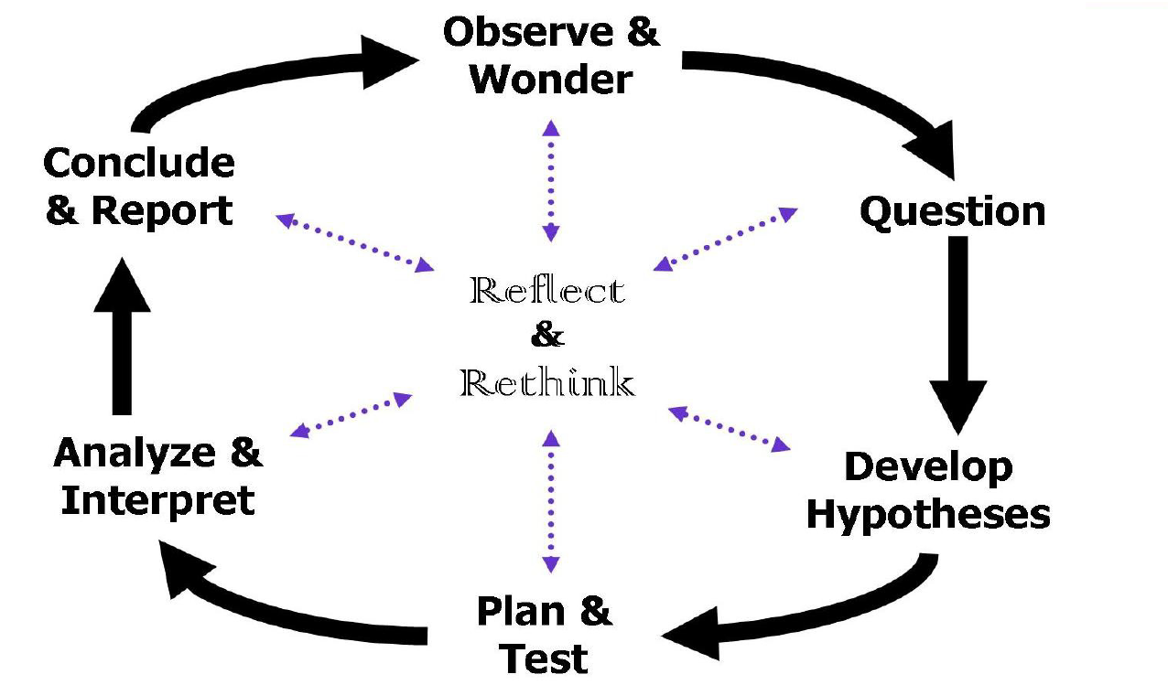
Process of Inquiry

GPS (Global Positioning System) and
GIS (Geographic Information System) Contests

General Guidelines

- Contestants must enter as a team. A team must consist of 2 - 4 members.
- The team of contestants must be certified by the county 4-H Agent or the Club Volunteer.
- Teams must be submitted or registered by official entry form by the specified date.
- Each team may have 1 coach present with them throughout the competition. The coach is not to provide answers, only technical assistance if there is a problem with software or hardware.
- Adult representatives from counties not participating in the competition are welcome to observe in designated areas.
- Only contestants and designated officials will be allowed within the designated perimeter of the contest.
- Contestants will compete on a team basis. There are no individual scores, only one team score.
- A team captain should be selected prior to the competition and designated on the registration form.
- Each team should provide the appropriate hardware and software needed to compete in the competition.

Resources:
arcgisonline.com

Contact persons:
Jeff Fellers, Union County fellers@clemson.edu 864-427-6259, Ext. 115
Beverley Connelly-Brown bconnel@clemson.edu 843-255-6060, Ext. 113

4-H GPS (Global Positioning System) Competition
(30 minutes)

Background
The GPS contest will be set up using a Garmin GPS unit. The coordinate system that will be used is degree decimal minutes (DDM). This is a decimal version of Degree Minutes Seconds. DDM is used by geocachers and a growing number of other GPS enthusiasts. In this format, coordinates look like this:
Example: N47° 37.216' W122° 19.75'.
The north/south and east/west position remains unchanged. The difference is that the seconds part of the location is converted to a decimal by dividing the seconds by 60. Position format is a feature that should be adjustable in the GPS unit.

Objective
Contestants will work as a team to complete the score sheet in the allotted time (30 minutes). The course will have alphabetic stamps hidden at known coordinates just like a geocache would be hidden. Teams will be given coordinates on a sheet of paper at the competition and the time clock will begin. Following the given coordinates in exact order will formulate a word or phrase for the team. Each team will have a different word or phrase that they must complete. Each team will have to find the same number of points.

Rules
- Teams will consist of a minimum of 2 participants and a maximum of 4 participants.
- Each team may only use 1 GPS unit during the contest.
- Each team will be given 1 score sheet to record the letters they find.
- Each coordinate must be found and the letter must be written and stamped on the score sheet. An unstamped letter does not receive points.
- Scoring: Points will be awarded for each letter found. Each letter will carry the same point value. If the entire word or phrase is not completed during the allotted time a team is still eligible to receive points for the letters found. If more than one team completes the word or phrase in the allotted time, the team that finished first and correctly will receive first place.

Example Score Sheet
(Score sheet used during competition may vary in number of points)

Point 1:
Coordinates: N 34º 06.847’ W 080º 50.910 Letter _________ Stamp:

Point 2:
Coordinates: N 34º 06.847’ W 080º 50.910 Letter _________ Stamp:

Point 3:
Coordinates: N 34º 06.847’ W 080º 50.910 Letter _________ Stamp:

Point 4:
Coordinates: N 34º 06.847’ W 080º 50.910 Letter _________ Stamp:

Point 5:
Coordinates: N 34º 06.847’ W 080º 50.910 Letter _________ Stamp:

Point 6:
Coordinates: N 34º 06.847’ W 080º 50.910 Letter _________ Stamp:

Point 7:
Coordinates: N 34º 06.847’ W 080º 50.910 Letter _________ Stamp:

Point 8:
Coordinates: N 34º 06.847’ W 080º 50.910 Letter _________ Stamp:

Point 9:
Coordinates: N 34º 06.847’ W 080º 50.910 Letter _________ Stamp:

Word or Phrase: ____________________________________________________________

GIS (Geographical Information System)/GPS (Global Positioning System) Competition
(1 Hour)

Background
The GIS/GPS competition will require teams to bring both a computer and a GPS unit. Base data will be provided that is available to every team. The competition part will require teams to map set objects and then use that data to overlay on the base data. Mapping skills and data collection are the skill sets required for this competition.

Objectives
Contestants will work as a team to collect data with GPS units on the grounds of the competition. After collecting the data, the team will produce a map that neatly displays the data they collected. Teams will need to know how to import collected data from GPS units, while also knowing how to use existing shapefiles that will be provided to the team during the competition.

Rules
- Teams will consist of a minimum of 2 participants and a maximum of 4 participants.
- Each team may only use 1 GPS unit during the contest.
- Each team may only use 1 computer during the contest.
- Teams will be given a list of features to map on the grounds (may include light poles, benches, buildings, areas, etc.)
- Teams will be given a CD with base data sets.
- Scoring will be based on two factors: the collecting of data and the mapping of data. Each feature will have an equal point value. Maps will be judged on neatness and readability. Other criteria may be specified the day of the contest - for instance, labeling features on the map such as light poles, specific building names, roads, etc.

GIS (Geographic Information Systems) Competition
(30 Minutes)

Background
The GIS competition will require teams to produce a map with a given data set. It is recommended that you use ArcGIS explorer, which can be downloaded from the ESRI website at: http://www.esri.com/software/arcgis/explorer/. It is important to check and make sure your program is up to date before the competition. ArcGIS explorer allows you to import shapefiles, which are common file type in GIS, and perform some editing tasks along with showing labels. There are numerous locations where you can download shapefiles for free. The Department of Natural Resources, Department of Health and Environmental Control, and the GIS data server at USC all offer free shapefiles and data.

Objective
Contestants will work as a team to create a map from data they are given. All teams will be working with the same data set to produce the same map for scoring purposes. Teams should be able to produce a map that is easy to understand and read. Teams may also be asked to perform tasks such as: measure distance and area, create a point, create a line, or create an area/polygon, etc. Participants will receive their mapping assignment when the competition begins.
Rules
- Teams will consist of a minimum of 2 contestants and a maximum of 4 contestants.
- Each team will need to bring a computer. Only one computer per team.
- Each team will be provided with one CD that contains the data necessary for the GIS Competition
- Scoring will be based on the map and a series of questions. There will be map components listed that each map should contain (for example: data set, labels, road names, created line segments or polygons, etc.). These criteria will each have a point value. There will also be questions that have to be answered off the map and they will have point values as well. These questions may include calculating distance, calculating acreage, or identifying the name of a street.

Rocketry Competition
1. SAFETY: All rockets must be built and flown in accordance with the Model Rocket Safety Code of the National Association of Rocketry. Rockets flown at the fly-off must have previously flown successfully. They will be inspected before launch and observed during flight by an event official, whose judgment on their compliance with the Safety Code and these rules will be final.
2. ROCKET REQUIREMENTS: Rockets may be any size, but must not exceed 650 grams (23 ounces) gross weight at liftoff. They may be commercially-made kits or personally designed. They must have only one stage. They must be powered only by commercially-made model rocket motors of “F” or lower power class that is recommended for your rocket. A launch pad will be provided, but participants must provide their own engines.
3. ALTITUDE SCORING: Rockets will be scored utilizing an “Alti Trak” altitude finder. Rockets will be divided according to the weight of the rocket and age categories.
Lightweights: 1 oz. or less
Medium Weights: 1 to 2 oz.
Heavy Weights: over 2 oz.

4. DURATION SCORING: Scores shall be based on total flight duration of the rocket from the first motion at liftoff from the launch pad until the moment of landing or until the rocket can no longer be seen due to distance or to an obstacle. Times must be measured independently by two officials. The official duration will be the average of the two times, rounded to the nearest 0.01 second. Rockets will be divided according to the criteria listed in the Altitude Scoring.
5. DESIGN AND FUNCTION: Rockets will be judged according to be the best design and function (fins installed properly, parts installed in the correct positions, etc. For this competition the rockets will be divided according to age and type of rocket (kit or personal design).
6. INDIVIDUALS AND TEAMS: Individuals or teams may enter. Teams should consist of 3 – 4 members.

Resources:
There are many resources for obtaining rockets, engines, and other materials, as well as educational materials, online.
www.estesrockets.com
http://www.nasa.gov/audience/forkids/kidsclub
www.nar.org/NARmrsc.html (for Model Rocket Safety Code)

Contact Persons:
Robin Currence, Chester County rcrrnc@clemson.edu 803-209-0538

MODEL ROCKET SAFETY CODE
1. Materials I will use only lightweight, non-metal parts for the nose, body, and fins of my
rocket.

2. Motors. I will use only certified, commercially-made model rocket motors, and will not
tamper with these motors or use them for any purposes except those recommended by
the manufacturer.

3. Ignition System. I will launch my rockets with an electrical launch system and
electrical motor igniters. My launch system will have a safety interlock in series with
the launch switch, and will use a launch switch that returns to the “off” position when
released.

4. Misfires. If my rocket does not launch when I press the button of my electrical launch
system, I will remove the launcher’s safety interlock or disconnect its battery, and will
wait 60 seconds after the last launch attempt before allowing anyone to approach the
rocket.

5. Launch Safety. I will use a countdown before launch, and will ensure that everyone is
paying attention and is a safe distance of at least 15 feet away when I launch rockets with D
motors or smaller, and 30 feet when I launch larger rockets. If I am uncertain about the
safety or stability of an untested rocket, I will check the stability before flight and will fly it
only after warning spectators and clearing them away to a safe distance. When conducting
a simultaneous launch of more than ten rockets I will observe a safe distance of 1.5 times
the maximum expected altitude of any launched rocket.

6. Launcher. I will launch my rocket from a launch rod, tower, or rail that is pointed to within
30 degrees of the vertical to ensure that the rocket flies nearly straight up, and I will use a
blast deflector to prevent the motor’s exhaust from hitting the ground. To prevent accidental
eye injury, I will place launchers so that the end of the launch rod is above eye level or will
cap the end of the rod when it is not in use.

7. Size. My model rocket will not weigh more than 1,500 grams (53 ounces) at liftoff and will
not contain more than 125 grams (4.4 ounces) of propellant or 320 N-sec (71.9 pound-
seconds) of total impulse.

8. Flight Safety. I will not launch my rocket at targets, into clouds, or near airplanes, and will
not put any flammable or explosive payload in my rocket.

9. Launch Site. I will launch my rocket outdoors, in an open area at least as large as shown
in the accompanying table, and in safe weather conditions with wind speeds no greater than
20 miles per hour. I will ensure that there is no dry grass close to the launch pad, and that
the launch site does not present risk of grass fires.

10. Recovery System. I will use a recovery system such as a streamer or parachute in my
rocket so that it returns safely and undamaged and can be flown again, and I will use only
flame-resistant or fireproof recovery system wadding in my rocket.

11. Recovery Safety. I will not attempt to recover my rocket from power lines, tall trees, or other dangerous places.

LAUNCH SITE DIMENSIONS
Installed Total Impulse (N-sec) | Equivalent Motor Type | Minimum Site Dimensions (ft.)
0.00--1.25 | 1/4A, 1/2A | 50
1.26--2.50 | A | 100
2.51--5.00 | B | 200
5.01--10.00 | C | 400
10.01--20.00 | D | 500
20.01--40.00 | E | 1,000
40.01--80.00 | F | 1,000
80.01--160.00 | G | 1,000
160.01--320.00 | Two Gs | 1,500

ROBOTICS

- Teams may have between 2 and 6 team members.

- May either use RCX or NXT robot kits.

- Must provide batteries.

- Bring robots disassembled. ALL TEAMS WILL START WITH A DISASSEMBLED ROBOT!!!

- Please inform on the registration form if you will need any type of materials (robot kit, laptop, etc.).

- Basic building plans will be provided OR you may use your own. Everyone will start with a disassembled robot.

- Every team will have same amount of time to assemble robot.

- Each team will be charged to run a basic set of tasks; guidelines will be provided that day. Be able to:

- Maneuver back and forth
- Maneuver around an object
- All while keeping robot confined in a designated space
9. Scoring will be on:

• Robot Design
• Successful programming for tasks
• Teamwork

Resources: Contact Laurie Lewis

Contact Persons:
Laurie Lewis Chester County wmllewis@truvista.net 803-374-7240

Wind Energy Contest

Modeled after an activity in The Power of Wind National 4-H curriculum, youth will work together in teams to exhibit knowledge of basic engineering principles and wind energy potential.
The contest is designed for those brand-new to wind energy activities, and is based on The Power of Wind lesson titled, “How Can We Use Wind to Lift a Load?” (See attached lessons). The contest will be open to teams of 3 - 4 Junior (ages 9 - 13) or Senior (ages 14 - 19) 4-H’ers.
Contest Structure
Objective: Design and build a wind turbine that uses wind power to lift a minimum of four pennies from ground-level to the top of a standard 6-foot table.
- Wind will be simulated using a standard box fan, which will be provided at the contest.
- Teams may bring one (1) box of materials matching the supply list listed on page 18 of The Power of Wind Youth Guide.
- It is recommended that teams pre-plan for design, materials, etc.
- Teams will be judged on the following:
  - Creativity of Turbine Design & Demonstration of the Engineering Design Process
  - Teamwork
  - Soundness of Design
    - How much time does the turbine take to lift a load of 4 pennies off the floor?
    - What is the maximum amount of pennies the turbine will lift?
  - Communication with Judges/Answering Relevant Questions
- Contest will last approximately 1.5 hours from start to finish.
- Awards will be presented at the conclusion of the contest.
Resources:
The Power of Wind, National 4-H Council (www.4-h.org)

Contact Persons:
Cyd Brown Greenville County cydb@clemson.edu 864) 232-4431 x125.

